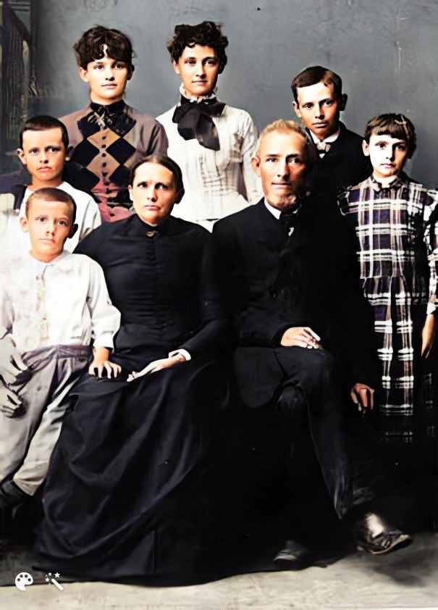
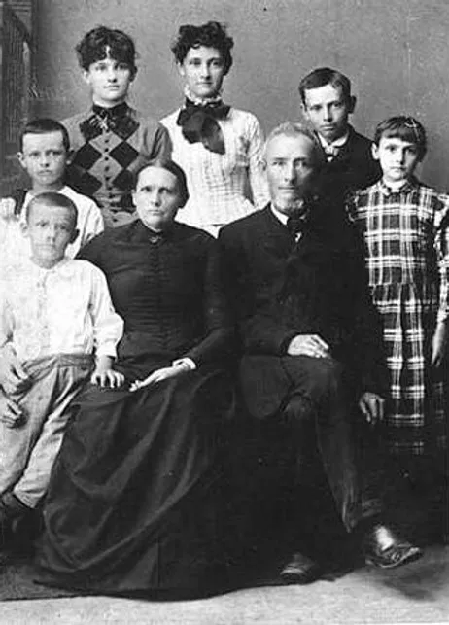
BRYCE FAMILY

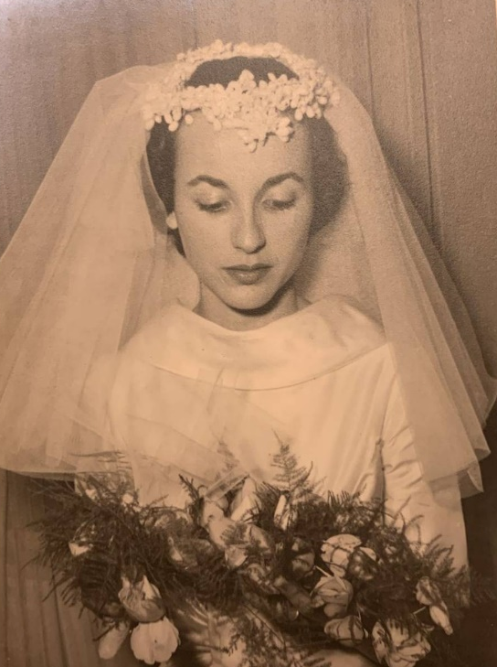
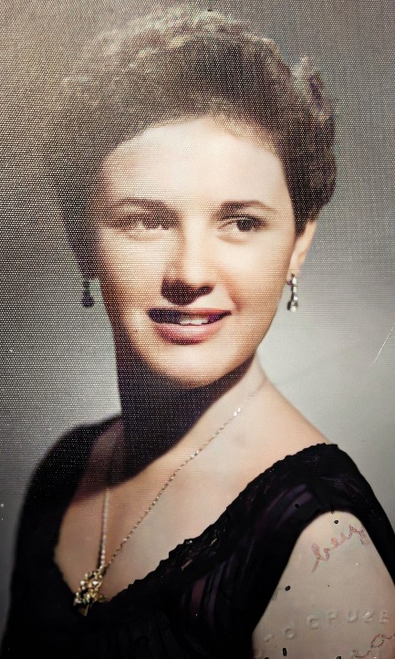
LILLIAN FRANCES SMITH DOS SANTOS JUNE KNIGHT COUBE
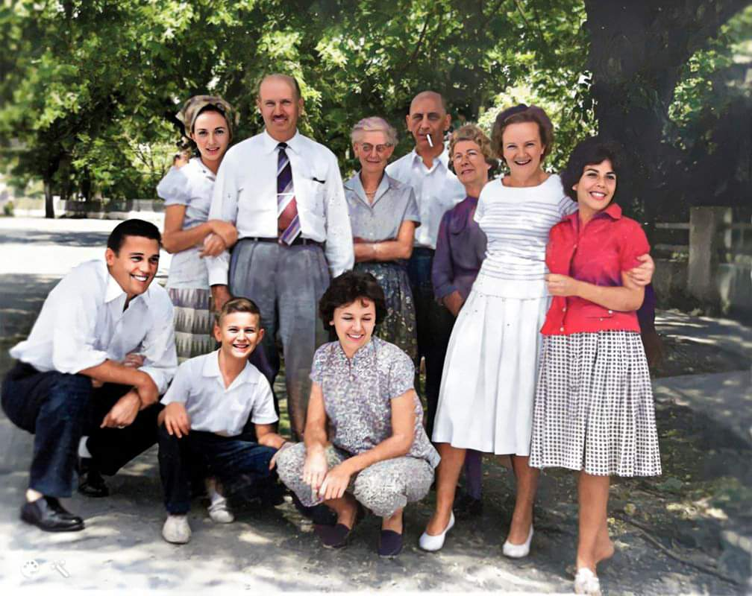
JUNE KNIGHT COUBE
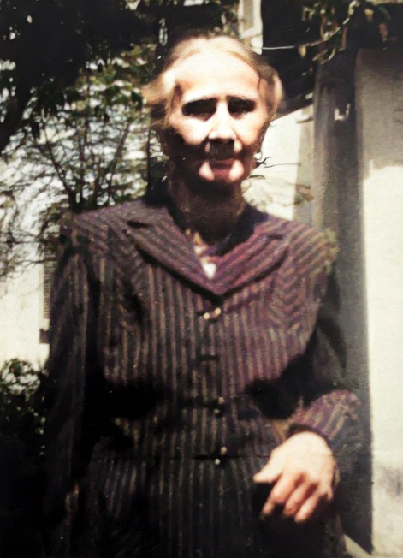

ELEONOR CONSTANCE SMITH Frances Miriam Alston Hawthorne

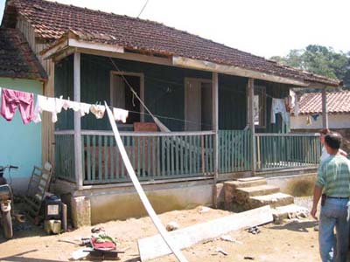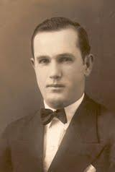
Alfred Iverson Smith House 2003 Sir HENRY ALSTON SMITH
MARIA TERESA RIZZO SMITH
Henry Alston Smith
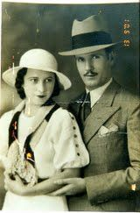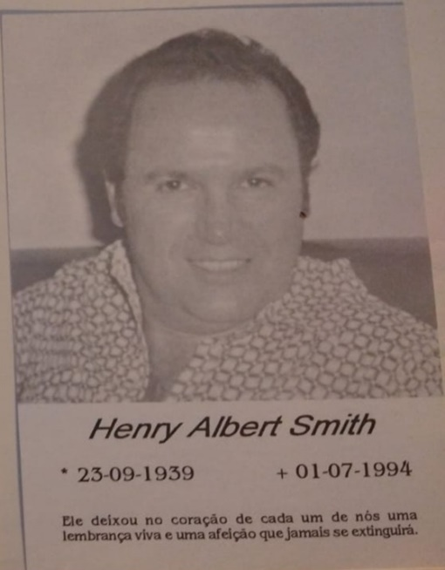

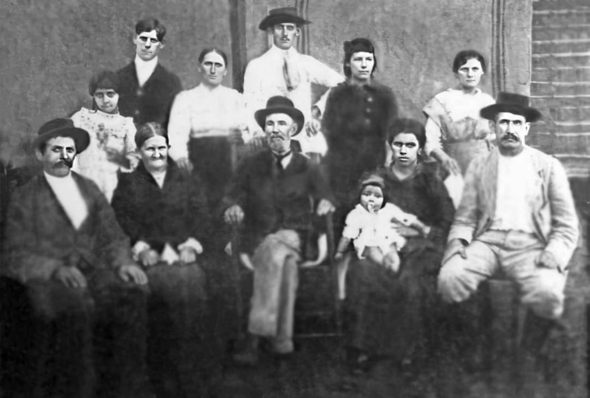
Eugene Billington SMITH family
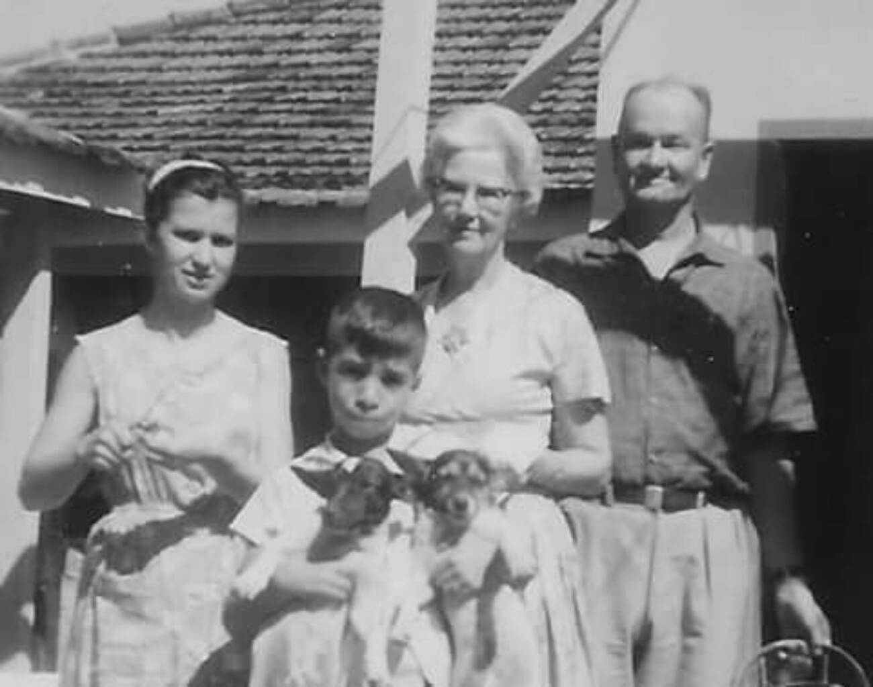
ARCHIBALD LESLIE SMITH Lillian Mercedes and Archer William Smith

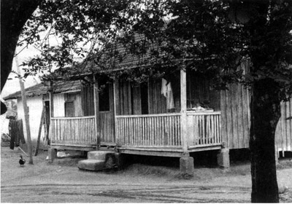
A;fred Iverson Smith house
James Fulton Bryce and family
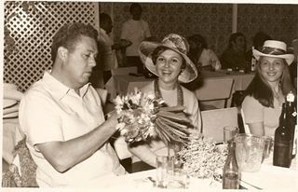
ELYSEU DOS SANTOS and LILLIAN FRANCES SMITH DOS SANTOS
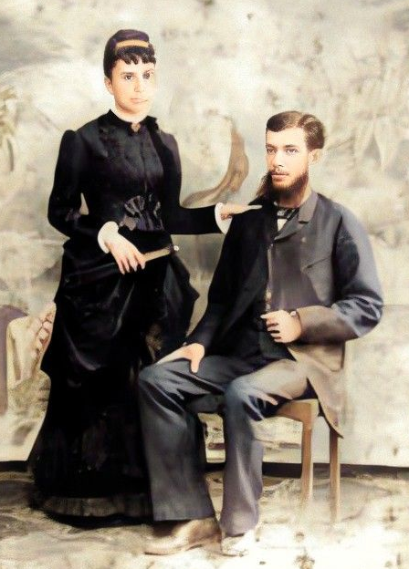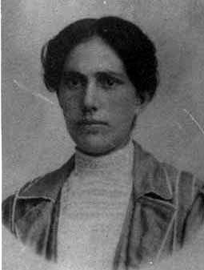
Alfred Preston Smith Lydia Odorinda ---------

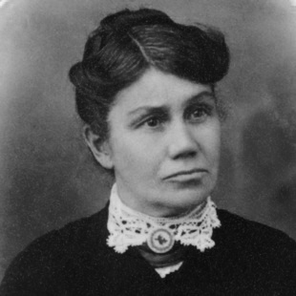
Sarah Ballona Smith

